Practical Project Part 4

Full Name: Meet Maheta

Course Name: CST8333

Assignment Title: Programming Language Research Project - Practical Project Part 4

Submission Date: August 4, 2024

Evidence of Learning

**Implemented Feature: Vertical Bar Chart Visualization**

1. **Loading the Dataset (Lines 30-41)**

This part of the code loads the dataset from a CSV file and handles any potential errors.

1. **Parsing the Dataset (Lines 43-52)**

This function extracts value counts of the selected column from the dataset and handles cases where the column is not found.

1. **Creating the Vertical Bar Chart (Lines 54-69)**

This function generates and displays a vertical bar chart using the data from the selected column.

1. **User Interaction for Column Selection (Lines 71-89)**

This function displays the available columns to the user and prompts them to select one for visualization.

1. **Main Menu for User Interaction (Lines 91-114)**

This part of the code provides the main menu for the user to either visualize a column or exit the program.

Program Demonstration via Screen Shots

1. **Main Menu**

Displays the main menu with options to visualize a column or exit the program.

1. **Column Selection**

Shows the available columns for visualization and the prompt for selecting a column.

1. **Visualization**

Displays the vertical bar chart for the selected column.

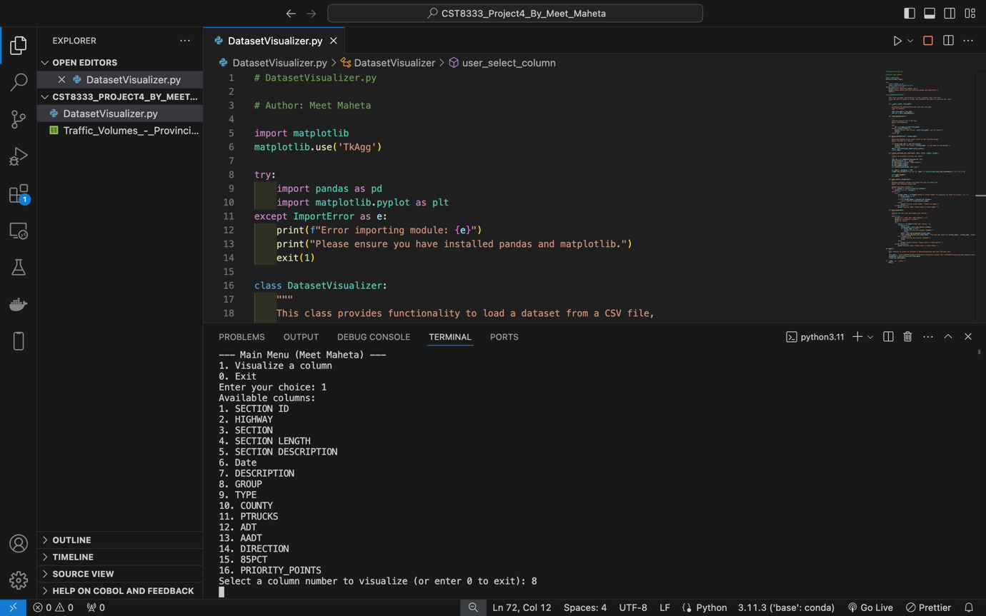

Source Code Commenting Example

**Source Code File: DatasetVisualizer.py**

# DatasetVisualizer.py

# Author: Meet Maheta

import matplotlib

matplotlib.use('TkAgg')

try:

import pandas as pd

import matplotlib.pyplot as plt

except ImportError as e:

print(f"Error importing module: {e}")

print("Please ensure you have installed pandas and matplotlib.")

exit(1)

class DatasetVisualizer:

"""

This class provides functionality to load a dataset from a CSV file,

allow the user to select a column, and visualize the data in a vertical bar chart.

"""

def __init__(self, file_path):

"""

Initialize the DatasetVisualizer with the file path.

Load the dataset.

"""

self.file_path = file_path

self.df = self.load_dataset()

def load_dataset(self):

"""

Load the dataset from a CSV file.

Return the DataFrame.

"""

try:

df = pd.read_csv(self.file_path)

except FileNotFoundError:

print(f"Error: The file at '{self.file_path}' was not found.")

exit(1)

return df

def parse_dataset(self, column_name):

"""

Parse the dataset to get value counts of the selected column.

Return the data as a Series.

"""

if column_name not in self.df.columns:

print(f"Error: The column '{column_name}' is not found in the dataset.")

exit(1)

data = self.df[column_name].value_counts()

return data

def create_vertical_bar_chart(self, data, title, xlabel, ylabel):

"""

Create and display a vertical bar chart.

"""

fig, ax = plt.subplots(figsize=(24, 12))

data.plot(kind='bar', ax=ax)

ax.set_title(f"{title} - Meet Maheta")

ax.set_xlabel(xlabel)

ax.set_ylabel(ylabel)

plt.xticks(rotation=90, ha='right')

n = max(1, len(data) // 50)

[label.set_visible(False) for (i, label) in enumerate(ax.xaxis.get_ticklabels()) if i % n != 0]

plt.tight_layout()

plt.show()

def user_select_column(self):

"""

Display available columns and prompt the user to select one.

Return the selected column name.

"""

print("Available columns:")

for i, column in enumerate(self.df.columns):

print(f"{i + 1}. {column}")

while True:

try:

column_index = int(input("Select a column number to visualize (or enter 0 to exit): ")) - 1

if column_index == -1:

return None

if 0 <= column_index < len(self.df.columns):

return self.df.columns[column_index]

else:

print("Invalid column number. Please try again.")

except ValueError:

print("Invalid input. Please enter a valid number.")

def main_menu(self):

"""

Display the main menu and handle user choices.

"""

while True:

print("\n--- Main Menu (Meet Maheta) ---")

print("1. Visualize a column")

print("0. Exit")

try:

choice = int(input("Enter your choice: "))

if choice == 1:

column_name = self.user_select_column()

if column_name is None:

print("Exiting the program. Goodbye!")

break

data = self.parse_dataset(column_name)

self.create_vertical_bar_chart(data, f"Vertical Bar Chart of {column_name}", column_name, "Frequency")

elif choice == 0:

print("Exiting the program. Goodbye!")

break

else:

print("Invalid choice. Please select a valid option.")

except ValueError:

print("Invalid input. Please enter a valid number.")

def main():

"""

Main function to create an instance of DatasetVisualizer and start the main menu.

"""

file_path = '/Users/mmb0702/Desktop/PLRP/Phase 4/Practical Project Part 4/CST8333_Project4_By_Meet_Maheta/Traffic_Volumes_-_Provincial_Highway_System.csv'

visualizer = DatasetVisualizer(file_path)

visualizer.main_menu()

if __name__ == "__main__":

main()